Prezi Presentation:
FBI Famous Cases

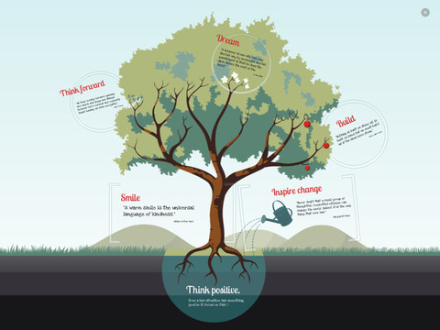

You are creating a Prezi presentation using the research you have already conducted.
Your Prezi must include:
Title
Case Summary – 5 points
Timeline of Events – 10 points
Resolution – 5 points
Three Relevant Graphics – 3 points each
Evaluation of the lasting impact of case the case – 15 points
Works Cited – 6 points
Total: 50 points

This presentation will be reviewed by both your peers and me, and there will be an evaluation grade for this assignment as well!
Other Requirements
-Length should be 3-4 minutes
-Expectation is that grammar and spelling are STANDARD English and not TEXTING English (free from error)
-If you do not have a Prezi account, you must sign up for an account. www.prezi.com

